Exam #2
Introduction to Astronomy and Astrophysics NAME ______________________
Spring 2007

Duration of exam: 2 hours

You may use a calculator and the crib sheet provided. Please do your own work. If you collaborate with other students or use materials which are not allowed on this exam, you will receive a substantial penalty.

True/False (2 points each, 12 points total)

______ 1. The period between pulses of radio waves from a pulsar depends on the frequency at which the pulsar is observed.

______ 2. Pulses of radio waves from a pulsar arrive at the Earth at different times in different frequency bands.

______ 3. If a star has CaII absorption lines, it means there are calcium atoms with one electron removed (singly ionized) in the star’s atmosphere.

______ 4. The Sun will eventually become a white dwarf within a planetary nebula.

______ 5. The iron in your blood was created in supernova explosions.

______ 6. If a material has a high opacity, then it does not let light travel very far before it is scattered.

Multiple Choice (2 points each, 24 points total). Choose the best answer.

______ 1. The rotation period of a pulsar:
(a) decreases with time.
(b) increases with time.
(c) initially decreases, but later increases with time.
(d) is constant with time.

______ 2. Two stars with the same spectra type have the same:
(a) luminosity
(b) temperature
(c) absolute magnitude
(d) apparent magnitude

______ 3. Which two things would allow and astronomer to determine the distance to a star?
- spectral type and luminosity class
- apparent magnitude and intrinsic luminosity
- temperature and absolute magnitude
- radius and temperature

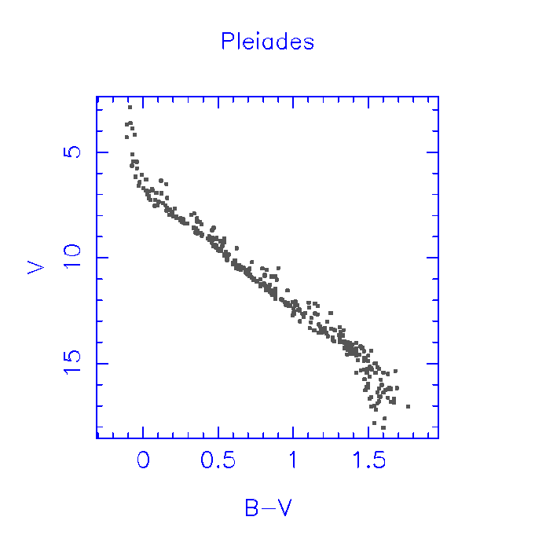

______ 4. The H-R diagram above depicts the stars in:
- a globular cluster
- an open cluster
- a galaxy
- the instability strip

______ 5. The stars in the diagram above are all
- the same age
- the same mass
- the same luminosity
- the same spectral type

______ 6. Of the following choices, which star is the hottest?
(a) A0 V
(b) G2 IV
(c) M0 III
(d) K5 III

______ 7. The majority of a star's life is spent in which evolutionary stage?
- pre-main-sequence (PMS)star
- main-sequence star
- red giant star
- asymptotic giant branch star
- horizontal branch star

_____ 8. Which is not a characteristic of luminosity class III (giant) stars?
- brighter than luminosity class V (main sequence) stars of the same spectral type
- bigger than luminosity class V (main sequence) stars of the same spectral type
- bluer than luminosity class V (main sequence) stars of the same spectral type
- lower surface gravity than luminosity class V (main sequence) stars of the same spectral type

______ 9.When a spherical mass contracts, it looses gravitational potential energy. What fraction of that energy is converted to kinetic (or thermal) energy?
- one quarter
- one third
- one half
- all of it

______ 10. The depth (or strength) of an absorption line in a stellar spectrum is determined by:
- The amount of each element on the surface of the star.
- The temperature on the surface of the star.
- The ionization states of the elements on the surface of the star.
- All of the above.

______ 11. The which of the following signals the death of a star?
- Supernova explosion
- Helium flash
- The triple alpha process
- All of the above.

______ 12. Which equation describes mathematically the concept that in equilibrium the pressure pushing each piece of the star out must equal the gravitational force pulling it in?
- The equation of hydrostatic equilibrium
- The mass continuity equation
- The equation of state
- The centripetal equation

Definitions (2 points each, 6 points total)

1. main sequence star –

2. brown dwarf –

3. Balmer line -

Problems requiring calculation (33 points total)

You must show your work (and units) to receive credit. Partial credit will be assigned.

1. (4 points) What is the combined absolute magnitude of a binary system consisting of two stars of absolute magnitude 0 and 3?

2. (a) (4 points) Estimate the luminosity, in units of solar luminosities, of a two solar mass star.

(b) (2 points) Estimate the radius, in units of solar radii, of a two solar mass star.

(c) (4 points) Estimate the effective temperature of a two solar mass star.

(d) (4 points) Estimate the ratio between the lifetime of a two solar mass star and the lifetime of the Sun.

3. (a) (4 points) What is the average density of the Sun?

(b) (3 points) If the Sun is composed entirely of ionized hydrogen, what is the average number density of particles?

(c) (4 points) If the mass of a ⁴He atom is 4.0026 amu and the mass of a ¹H atom is 1.0078 amu, how much energy is produced in creation of on helium nucleus from hydrogen?

(d) (4 points) How many hydrogen atoms are destroyed per day in the Sun?

Essay (25 points total)

I am looking for a clear and readable explanation in response to this question. Please use complete sentences. Diagrams or equations can be included if they clarify what you are writing (and count for credit). Complex sentences may be judged to contain more than one information unit, and may count for additional credit. I cannot read your mind, so you will have to write what you are thinking on the paper.
Two points will be added for correct and relevant pieces of information (sentences, drawings, equations with explanation), and three points will be subtracted for sentences which show misunderstanding of physics or astronomy. Five points are reserved for overall clarity and style of answer. No credit will be assigned for sentences that are illegible, contain repeated information, or are uninformative.
A minimum of ten informative sentences (and/or diagrams and/or equations) is required for full credit on this essay.

What is an H-R diagram, what parts of the diagram are occupied by stars, and what can we learn from them?

Astronomical Constants

Astronomical Unit AU = 1.496 x 10¹¹ m

Parsec pc = 206,265 AU
= 3.26 ly
= 3.086 x 10¹⁶ m

Light year ly = 6.324 x 10⁴ AU
= 0.307 pc
= 9.46 x 10¹⁵ m

Sidereal year 1 year = 365.26 days
=3.16 x 10⁷ s

Mass of Earth M⊕ = 5.98 x 10²⁴ kg

Radius of Earth R⊕ = 6378 km
at equator

Orbital velocity V⊕ = 30 km/s
of Earth

Mass of Sun M = 1.99 x 10³⁰ kg

Radius of Sun R = 6.96 x 10⁵ km

Luminosity of Sun L = 3.90 x 10²⁶ W

Effective temp T_{eff} = 5780 K
of Sun

Mass of Moon M_{Moon} = 7.3 x 10²² kg
= 0.0123 M⊕

Radius of Moon R_{Moon} = 1738 km
= 0.273 R⊕

Radius of Moon’s d_{Moon} = 3.84 x 10⁵ km
orbit

Sidereal month P_{Moon} = 27.3 days
Synodic month = 29.5 days

Distance of Sun R₀ = 8.5 kpc
from Galaxy center

Velocity of Sun V₀ = 220 km/s
aboutGalactic center

Diameter of Galaxy = 50 kpc

Mass of Galaxy M = 7 x 10¹¹ M

Physical and Mathematical Constants

Velocity of light c = 3.00 x 10⁸ m/s

Gravitational const. G = 6.67 x 10⁻¹¹ N m²/kg²

Planck constant h = 6.623 x 10⁻³⁴ J s

Boltzmann constant k = 1.38 x 10⁻²³ J/K

Rydberg constant R = 1.097 x 10⁷ m⁻¹

Stefan-Boltzmann σ = 5.67 x 10⁻⁸ W/(m² K⁴)
Constant

Wien’s Law const. λ_{max}T = 2.898 x 10⁷ Å K

Mass of hydrogen m_{H} = 1.67 x 10⁻²⁷ kg
atom = 1.0078 amu

Mass of helium atom m_{He} = 4.0026 amu

Mass of electron m_{e} = 9.11 x 10⁻³¹ kg

Charge of electron e = 1.60 x 10⁻¹⁹ C

Electron volt 1 eV = 1.602 x 10⁻¹⁹ J

π = 3.1416

e = 2.7183; log₁₀e = 0.4343

Atomic mass unit amu = 1.660539 x 10⁻²⁷ kg

Proton mass m_{p} = 1.007277 amu

Neutron mass m_{n} = 1.008655 amu

Kepler’s Laws

(1) The orbit of each planet is an ellipse with the Sun at one focus.
(2) The radius vector to a planet sweeps out equal areas in equal intervals of time.
(3) The squares of the sidereal periods of the planets are proportional to the cubes of the semimajor axes of their orbits.

a ae
a
a
b

Newtonian Physics

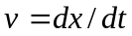
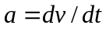
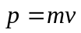
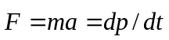
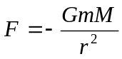
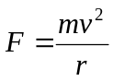 (for circles)
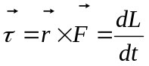
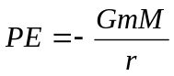
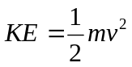
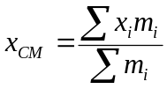
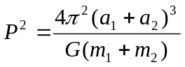
Electromagnetic Radiation

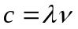
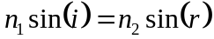
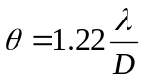
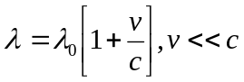
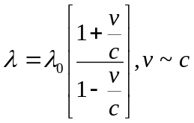
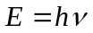
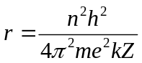
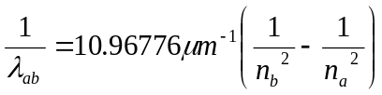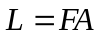

Blackbody Radiation
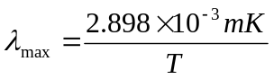
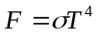
Properties of Planets

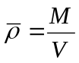
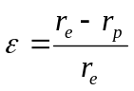

Atmospheres

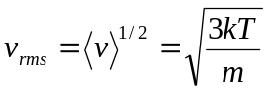
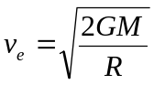

Tidal Forces

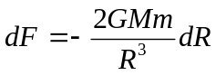
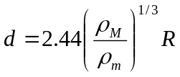

Stellar Structure

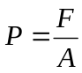
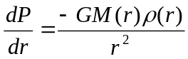
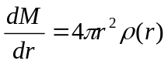
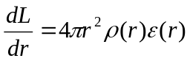
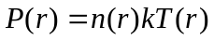
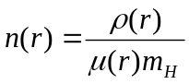
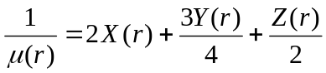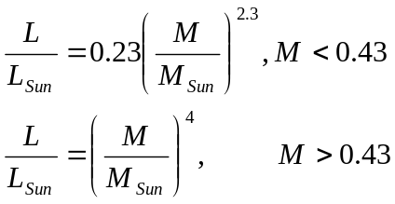
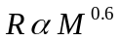

Viral Theorem

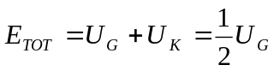
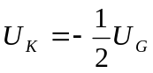

Magnitudes & Distances

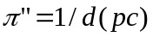
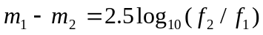
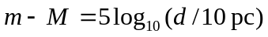
Color Index = m(λ₁) – m(λ₂)

Variable Stars

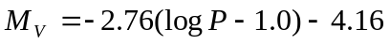 (period in days)

Stellar Counts
log N(m) = 0.6m + C
(const. density, single abs. mag.)

Redshift
z ≡ (λ-λ₀)/λ₀
≈ v/c for small z

Hubble’s Law
v = H₀d

Large z, flat Universe
d = cz(1+z/2)/[H₀(1+z)²]

Nova peak magnitude
M_{V}^{max} = -9.96 – 2.31 log(m)

Black Holes
R = 2GM/c²
= 3M km (M in M)

Cosmology
